KELCO INDUSTRIES
PMC PROCESS FLOW DOCUMENT

Login to Role: Administrator
Prerequisite for using PMC Setup (Employee Setup)

Navigation: Lists -> Employees -> Employees.
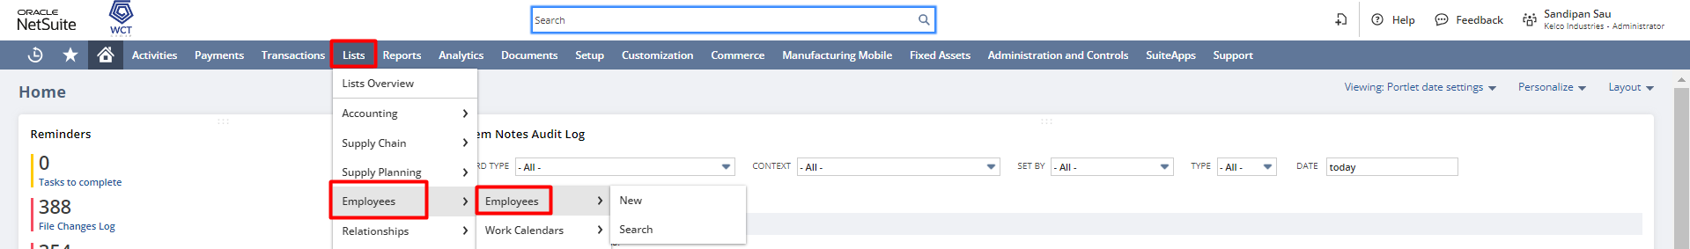
Edit the existing Employee record.
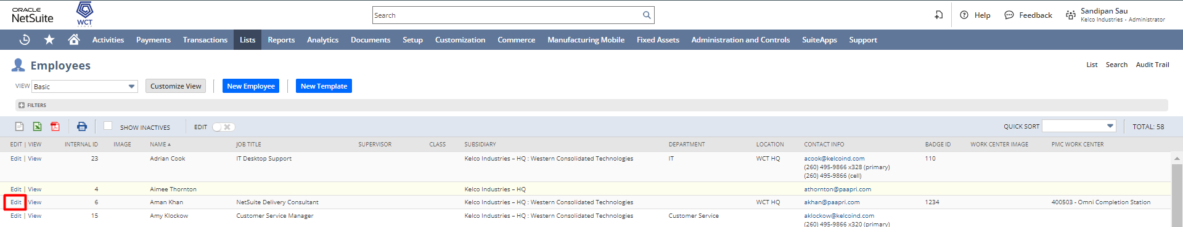
Add the “Badge Id” and select the “PMC Work Center” to the Employee record, and Save the employee record.
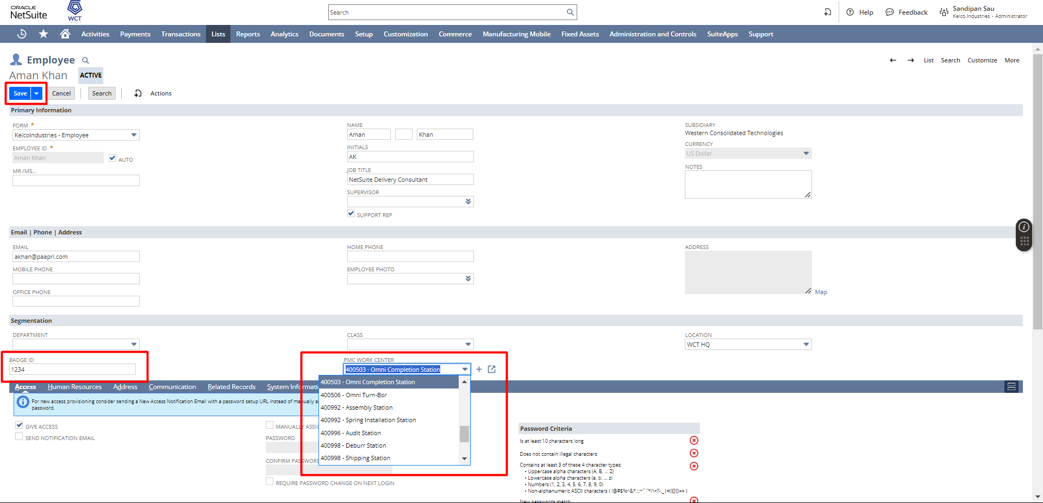
Note: The Badge ID has to be unique for each employee.

Create Work Order
Navigation: Transaction → Manufacturing → Enter Work Orders
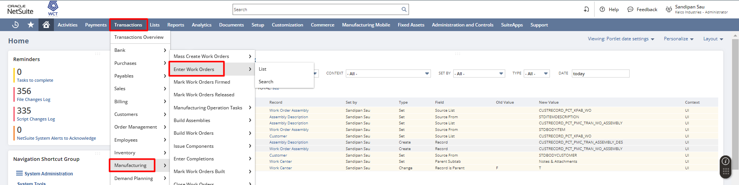
In the Work Order for put all the necessary details like “Subsidiary”, ”Assembly”, ”Quantity”, “Bill Of Material”, “Bill Of Material Revision”, “Manufacturing Routing” all others details and also checked the “WIP” checkbox then hit the Save button.
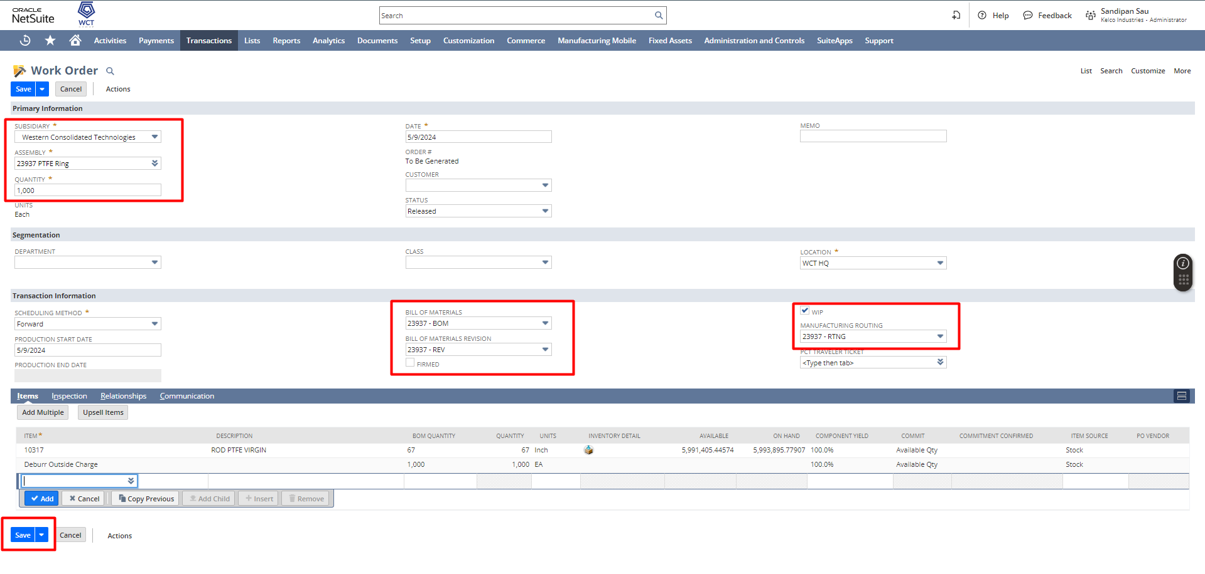

Create Work Order Issue
After saving the Work Order click on the Issue Components to start the issue components process.
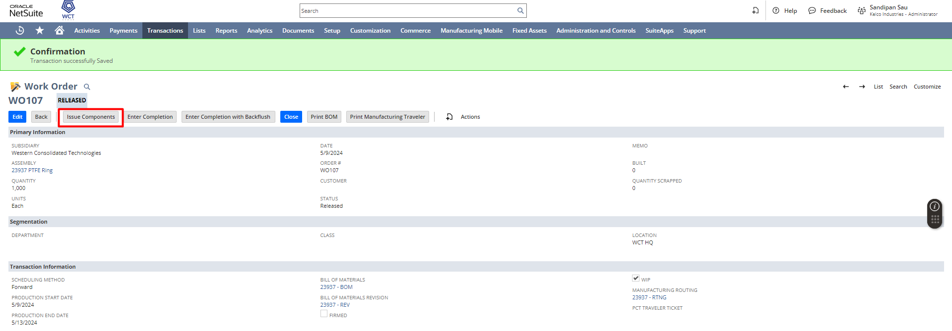
Select the Starting Operation and Ending Operation which signifies the sequence of operation, and configure the Inventory Details and click on Save.
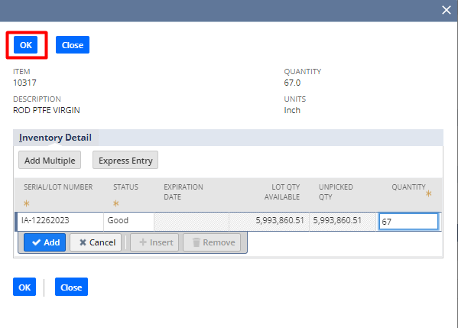
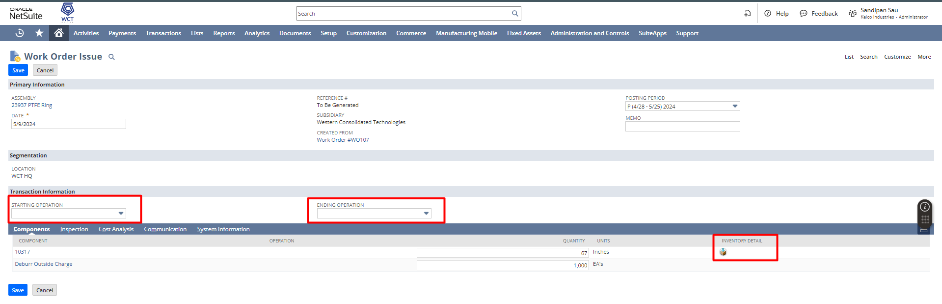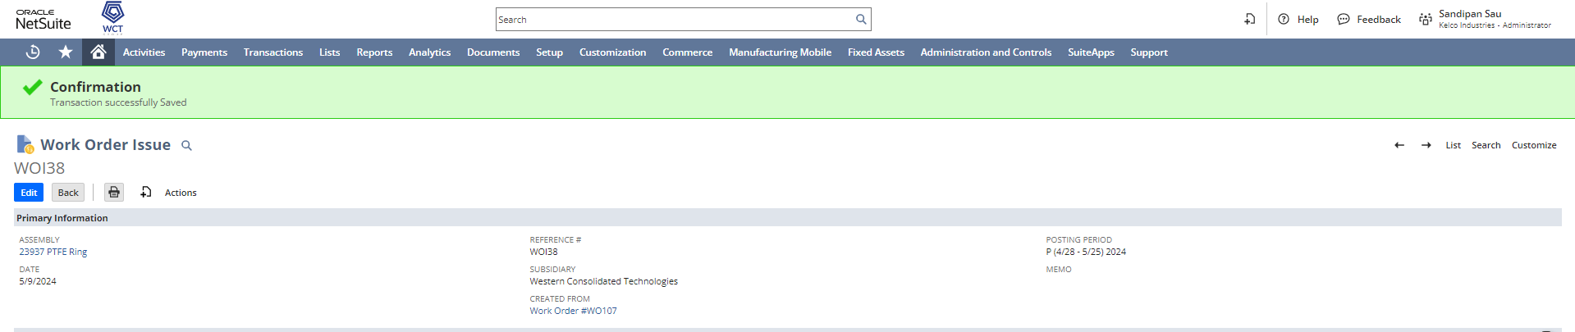
Login to PMC
Navigate to, Transaction -> PMC -> PMC
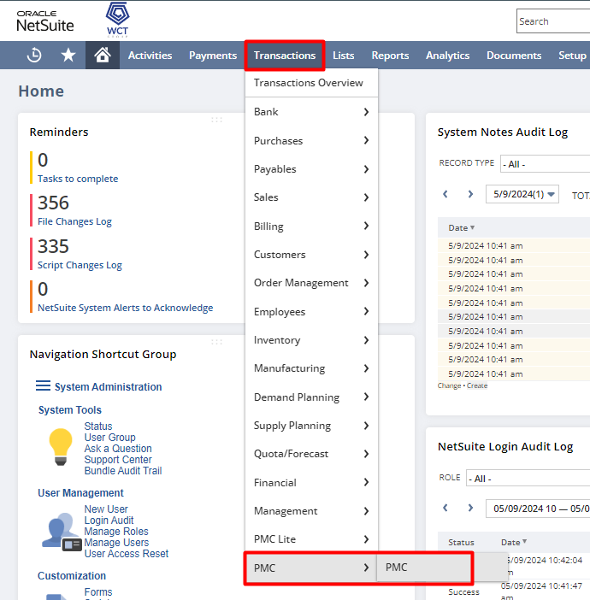
Provide the Badge Id, which you put in the Employee record, and click on LOGIN or hit Enter.

After click on LOGIN you will land on the PMC page, there are multiple sections in PMC page.
- User Details: Where you can find the User (Employee) details like Location, Work Center, also in this section you have the option to filter the Work Center although, the work center you mentioned in the Employee Record will be selected over here by default.
- Open Work Orders: Where you can find the Operations Table associated with that Work Center, which is being selected in the User Details section, along with some other details.
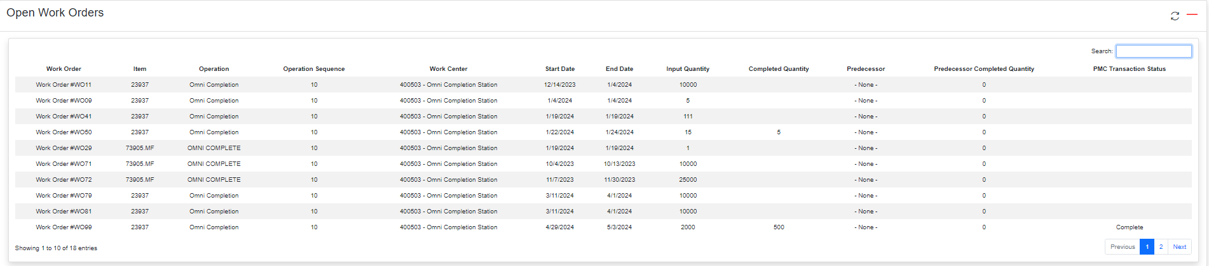
You have the ability to search anything in the table by using the search tab.
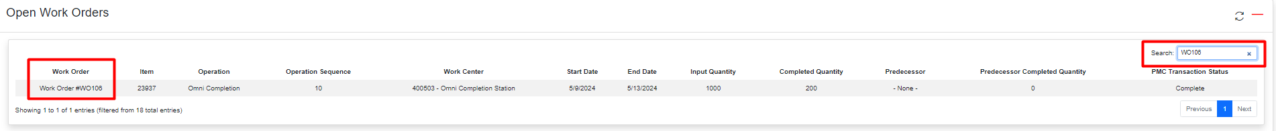
After select any specific row in the table, another two section will be populated.
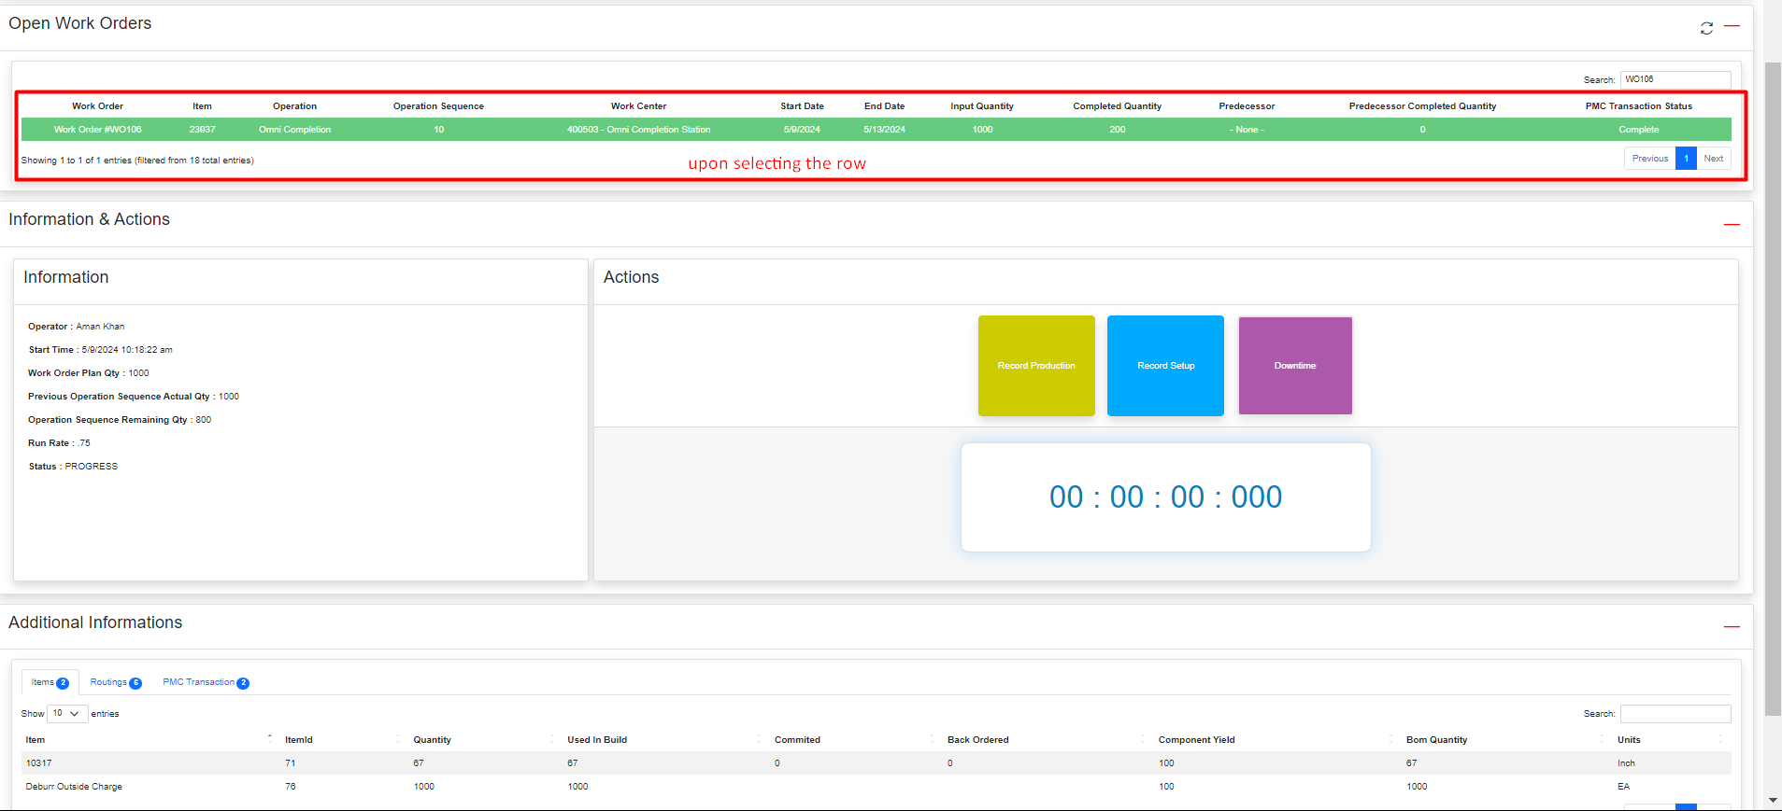
- Information & Actions: In the Information tab there are some relevant details regarding to that Operation. In the Actions tab, you can execute various PMC operations such as Recode Setup and Record Production, as well as schedule a Downtime and can monitor all the timing using the built-in clock timer system in PMC.
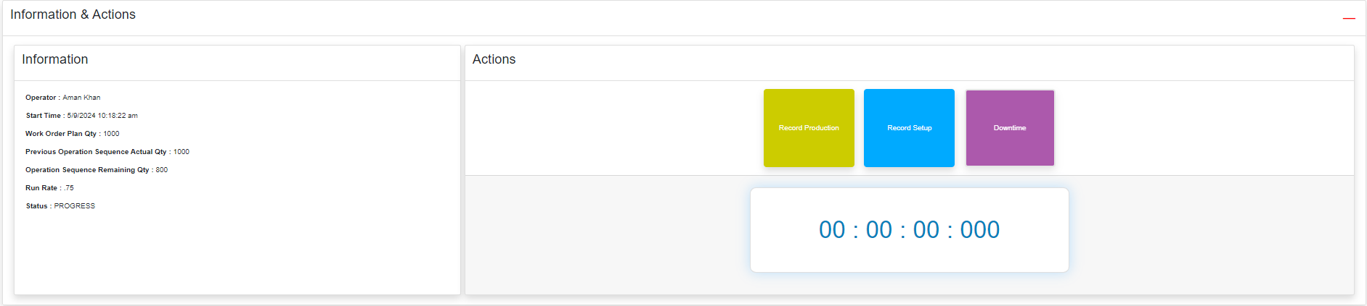
- Additional Informations : In this section, you will find tables for Items, Routings, and PMC Transactions. The details for Items and Routings primarily originate from the Work Order, and whenever you login in PMC or do any sort of tasks through PMC, a PMC Transaction Record is there to track those, so generated PMC Transaction associated with that operation will be displayed here.
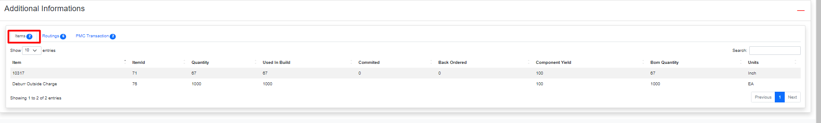
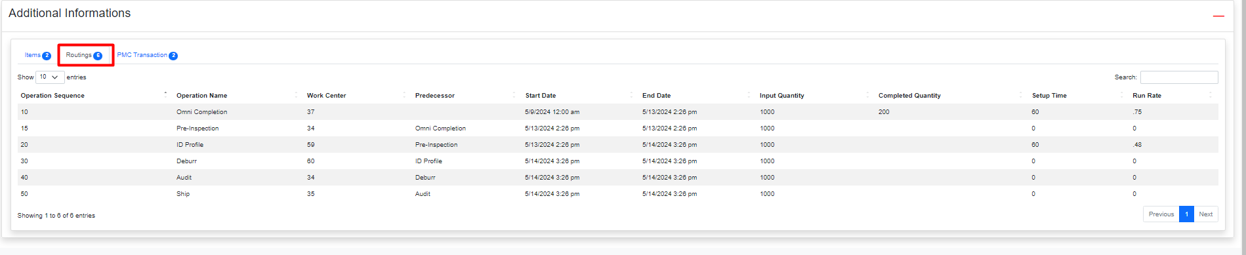
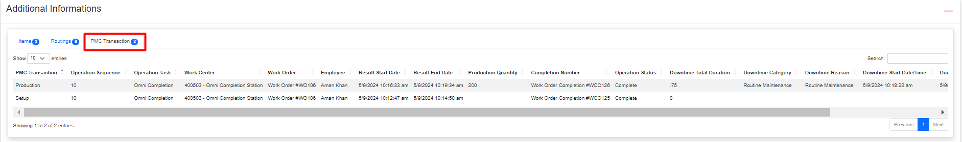

Record Setup
After selecting the specific Operation task from the Open Work Order tables, if you click on Record Setup button, it will start the PMC in build timer to track the record setup time, and the record setup is started.
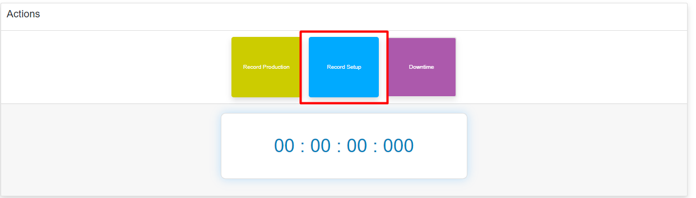

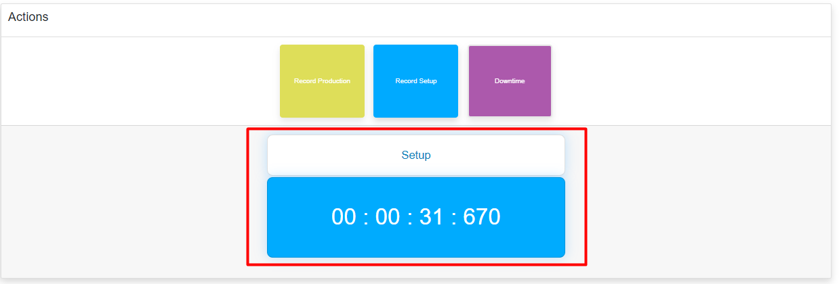
And to stop the Record Setup time click again on Record Setup button.

A Work Order Completion is created for the setup and for the confirmation you will see a success pop-up with a message “Work Order Completion Created” along with newly created Completion Id ( Internal Id ).
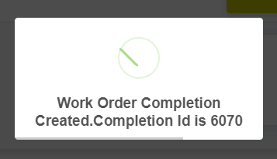
Also if you return to the Work Order and access the related records, you will find the newly created Completion Record. Upon opening this Completion Record and navigating to the Operation tab, you can view the time recorded for Setup (Machine Setup Time, Labor Setup Time), which is calculated through PMC.
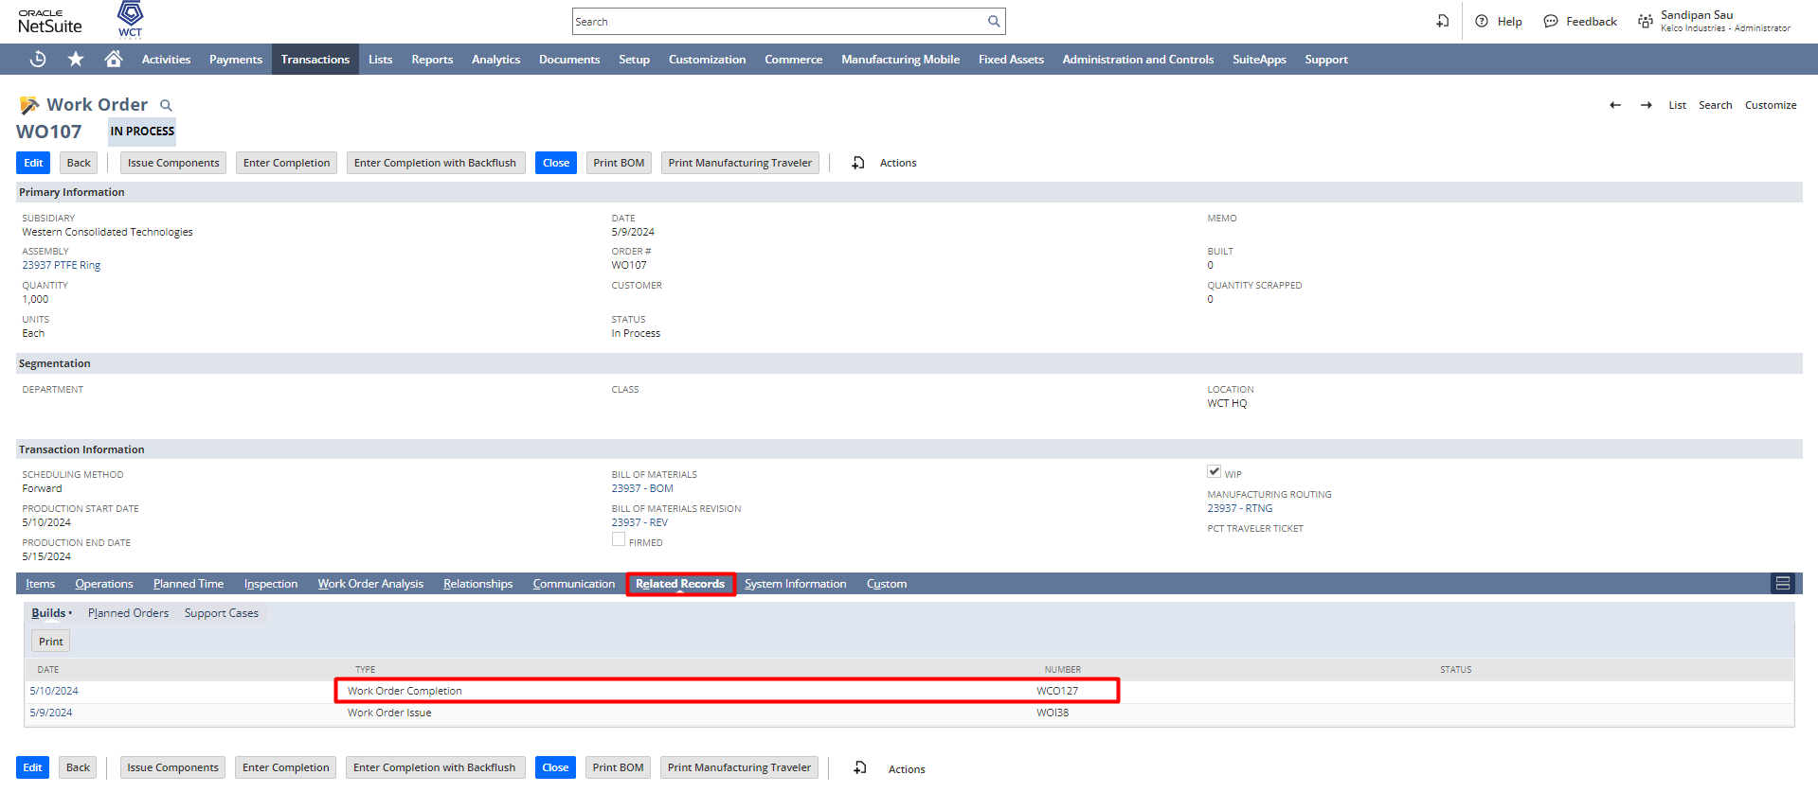
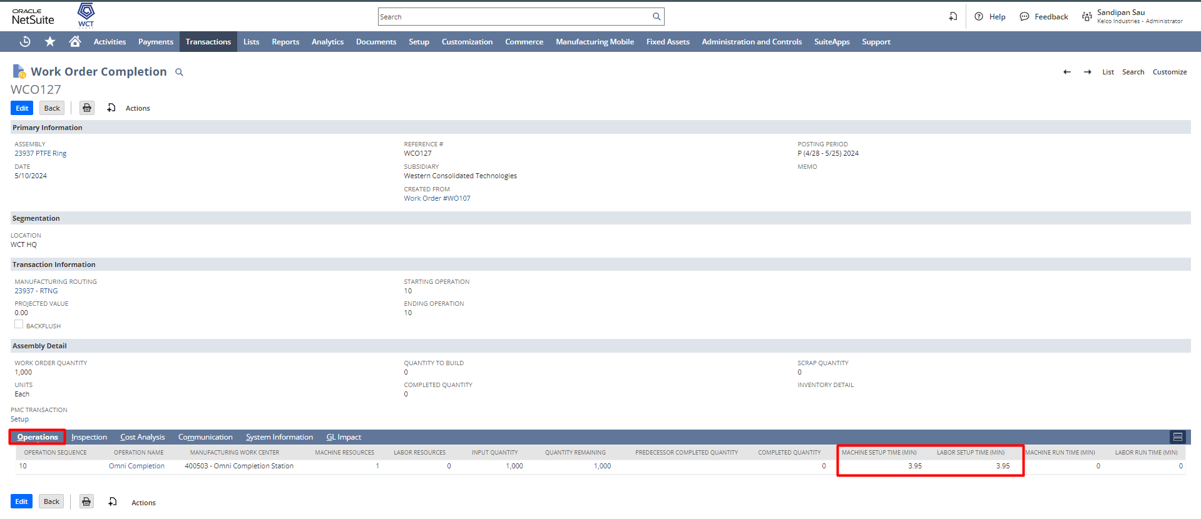
And if you click on the “PMC Transaction” field you can find the linked PMC Transaction record.
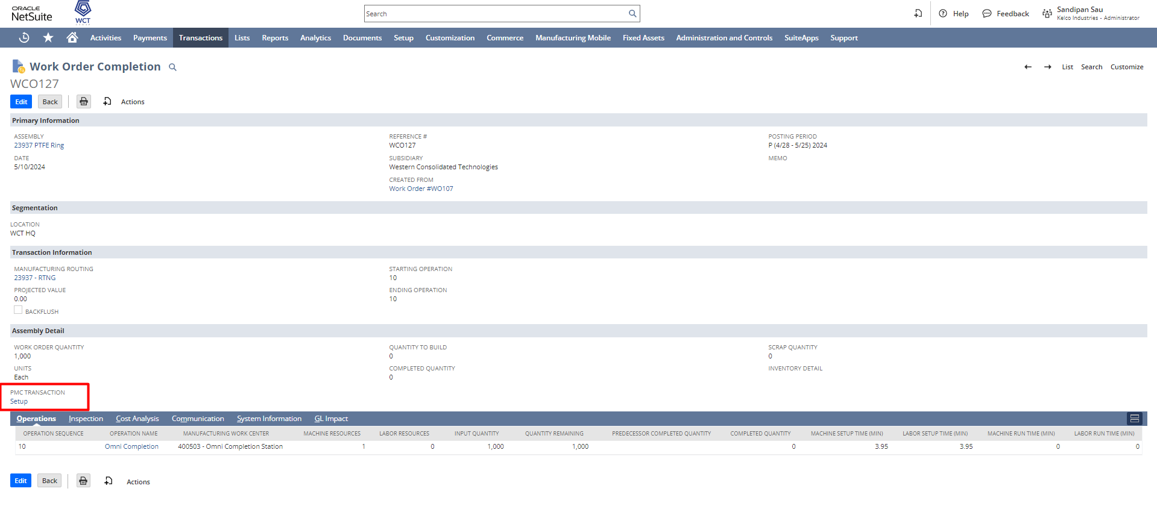
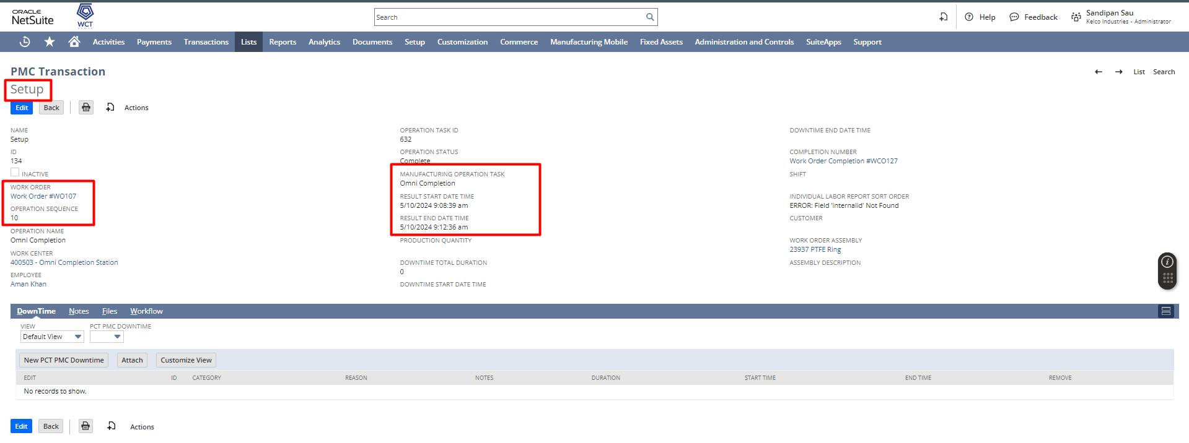

Record Production
To do the Record Production click on the Record Production button, and the timer will start again to track the Production time.


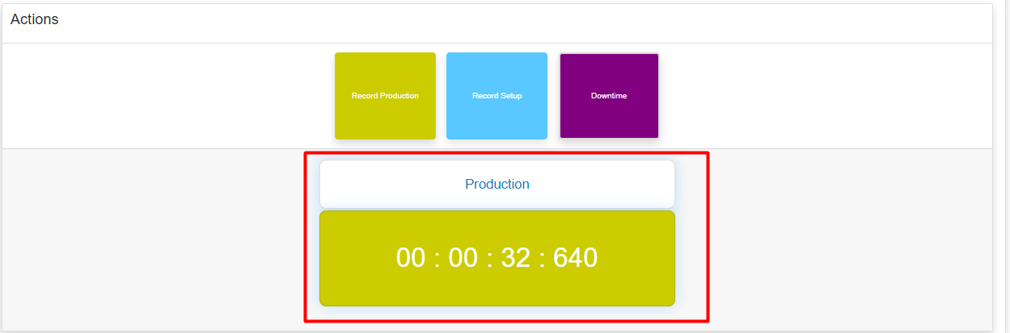

Downtime
If the user wants to stop the operation for some reason, they can have the ability to click on Downtime button.

Select the Downtime Reason, Notes for stopping the operation from the dropdown list and click on Submit.
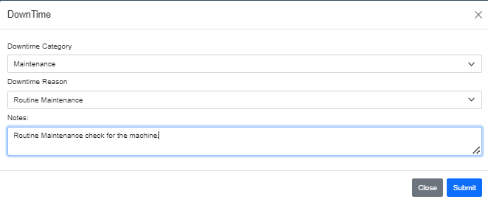
And you can find the Production timer is stopped and the Downtime timer is started to calculate the Downtime.
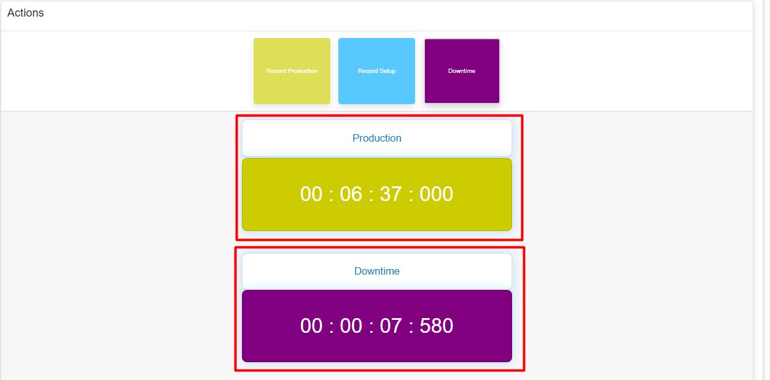

In order to resume the Operation or stop the downtime, click on Downtime button again, and the Production timer will start again.
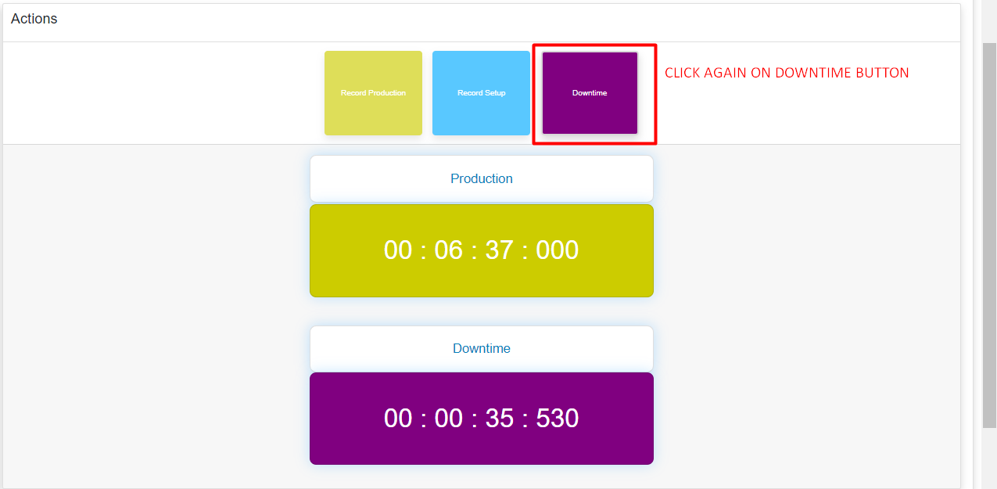
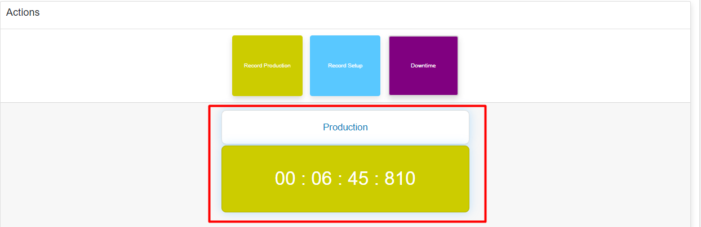
And to complete the Operation task click on Record Production button again, a pop-up will come for asking the Completed Production Quantity, put the quantity over there and click on OK.
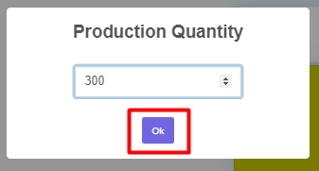
Upon clicking on Ok a success pop-up will come with a message “Work Order Completion Created” along with newly created Completion Id (Internal Id).
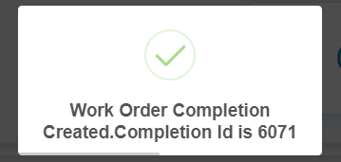

Also if you return to the Work Order and access the Operations tab you can find some quantities which you entered at the time of Production is being updated here as Completed Quantity.
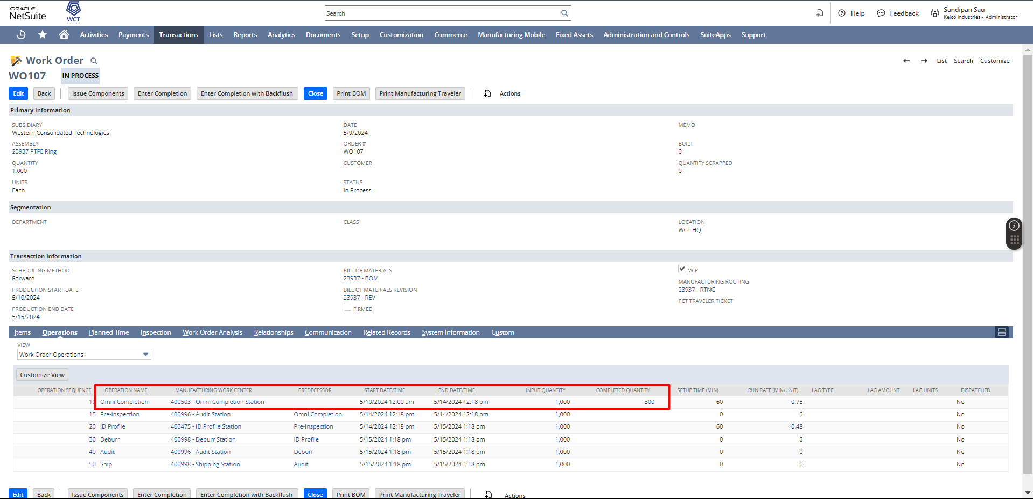
Also to access the Completion record go to the related records tab, you will find the newly created Completion Record. Upon opening this Completion Record and navigating to the Operations tab, you can view the time recorded for Production (Machine Run Time, Labor Run Time), which is calculated through PMC.
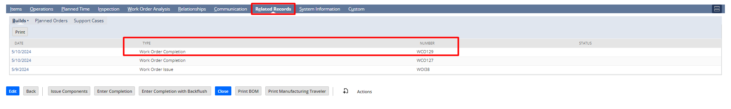
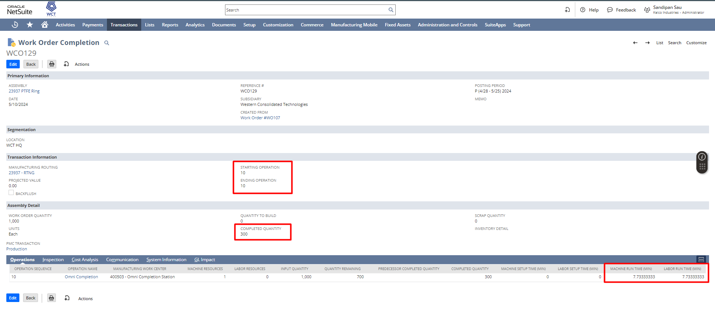
And if you click on the “PMC Transaction” field you can find the linked PMC Transaction record.
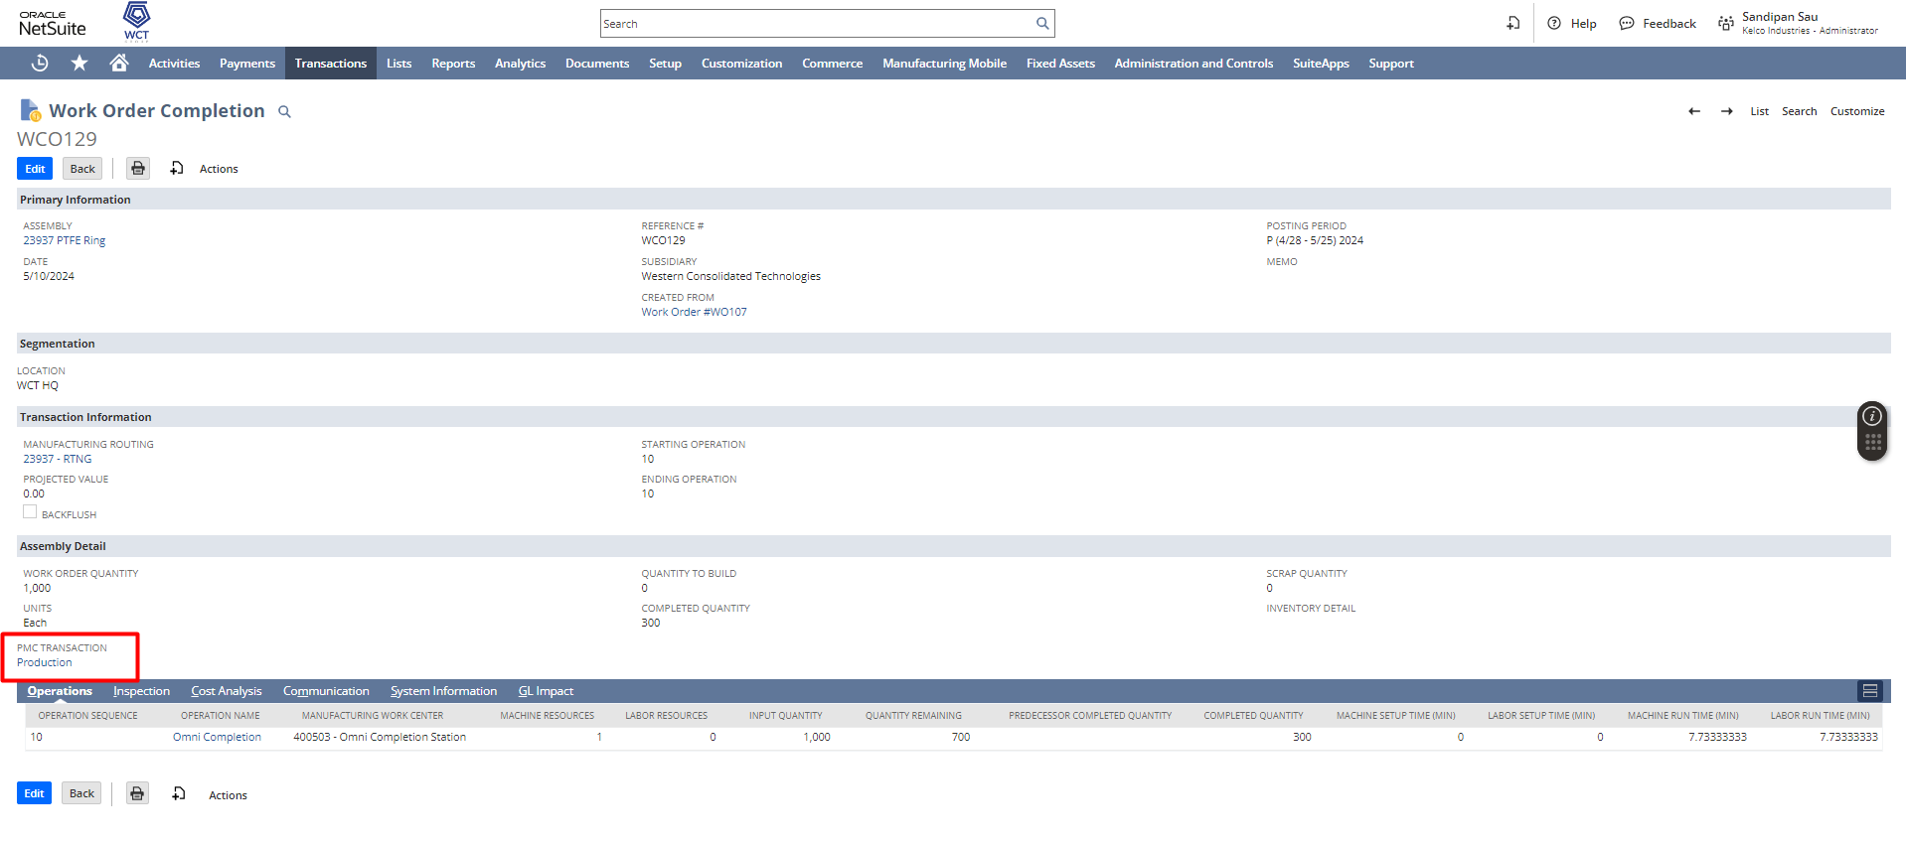
In PMC Transaction you can find various data like Operation Name, Sequence, Start Date, End Date, Completion Number, Work Order Number, Work Center Name, Production Quantity, Downtime Start & End Date, Downtime details etc to track the PMC Operation.
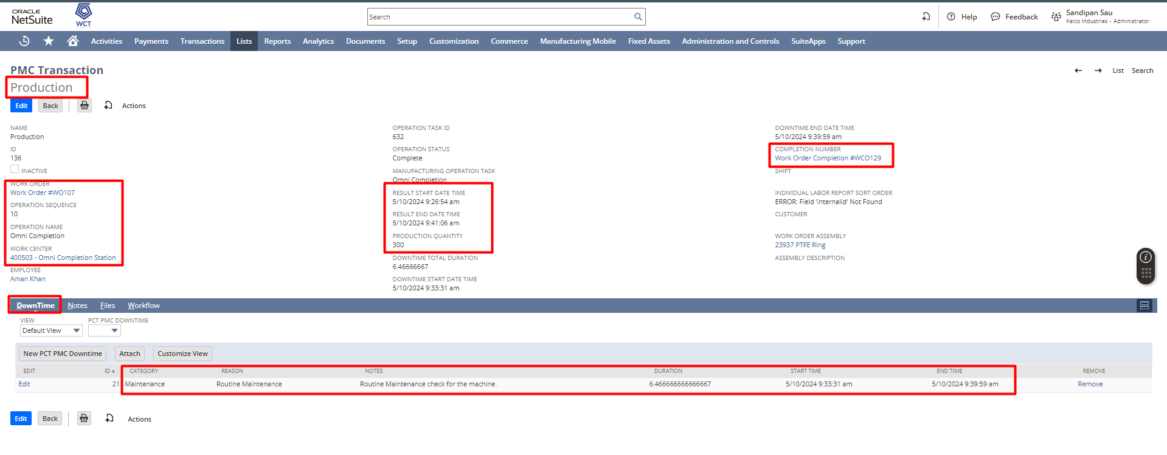

\

Signature: ________________________________
Date: _____________________________________

Disclaimer:
Upon signing off on the process flow document, you are confirming that the process has been set up per the SOW within NetSuite per your business's needs. Any changes or modifications requested after sign-off will need to be a "change request" at an additional fee.

*** PLEASE ensure that you have logged into NetSuite and tested the process prior to signing off on the setup. Paapri requires sign-off on this document prior to moving forward with any additional design meetings.

